# Rest API untuk Karyawan + Detail

1. **POST - {{host}}/v1/idstar/karyawan/save**

**Request Body** :

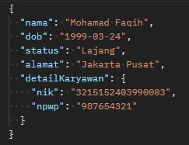

**Response body :**

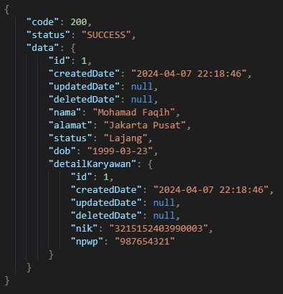

1. **PUT - {{host}}/v1/idstar/karyawan/update**

**Request Body :**

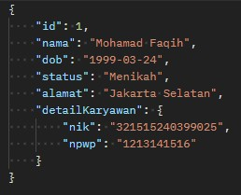

**Response Body :**

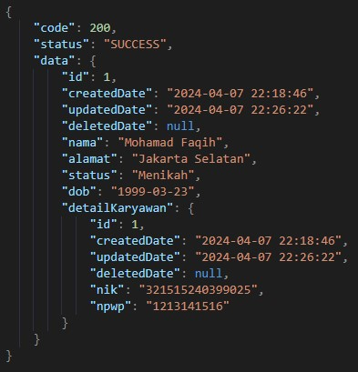

1. **GET LIST - {{host}}/v1/idstar/karyawan/list**

**Request Body :**

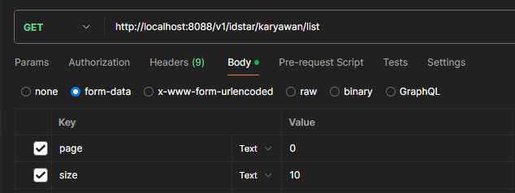

**Response Body :**

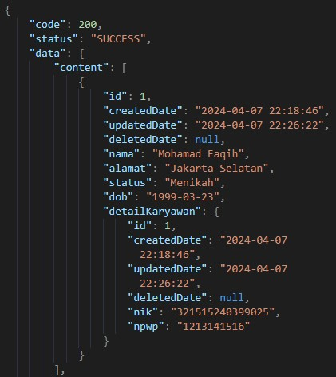

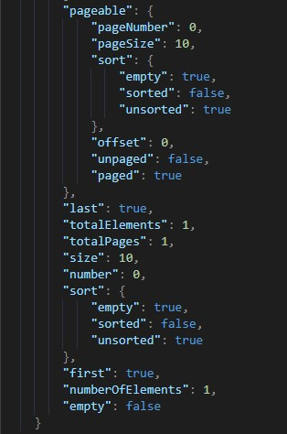



1. **GET ID - {{host}}/v1/idstar/karyawan/{id}**

**Request Body :**



**Response Body :**

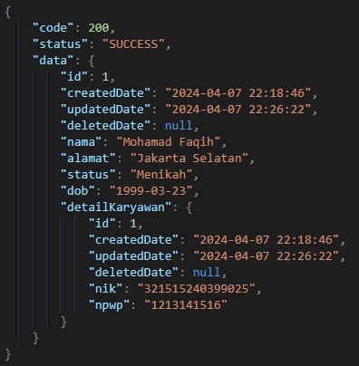

1. **DELETE - {{host}}/v1/idstar/karyawan/delete**

**Request Body :**



**Response Body :**

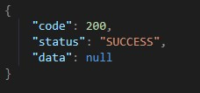

# 2. Rest API Untuk Rekening

1. **POST - {{host}}/v1/idstar/rekening/save**

**Request Body :**

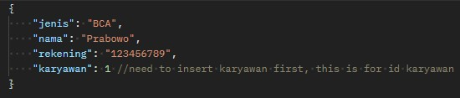

**Response Body :**

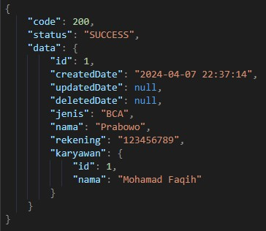

1. **PUT - {{host}}/v1/idstar/rekening/update**

**Request Body :**

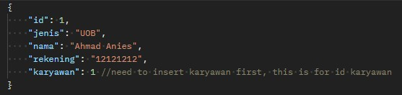

**Response Body :**

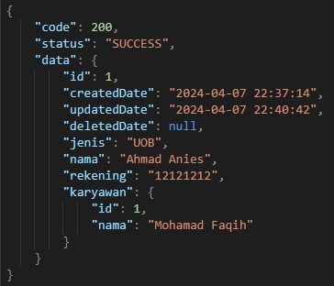

1. **GET LIST - {{host}}/v1/idstar/rekening/list**

**Request Body :**

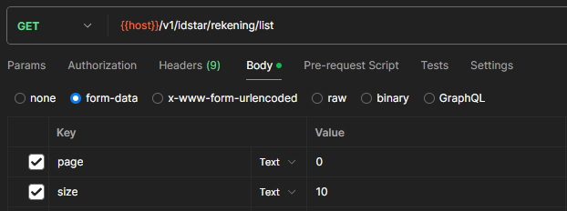

**Response Body :**

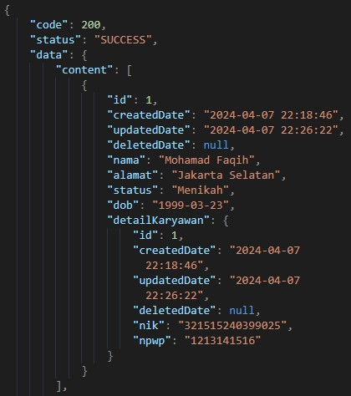

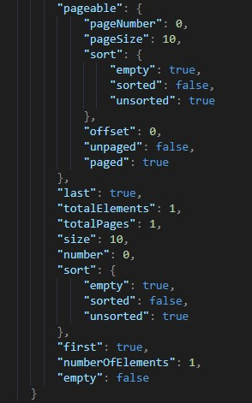



1. **GET ID - {{host}}/v1/idstar/rekening/{id}**

**Request Body :**



**Response Body :**

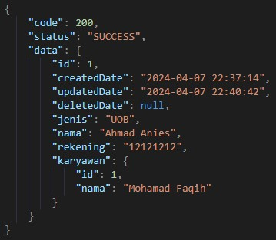

1. **DELETE - {{host}}/v1/idstar/rekening/delete**

**Request Body :**



**Response Body :**



# 3. Rest API Untuk Training

1. **POST - {{host}}/v1/idstar/training/save**

**Request Body :**

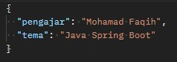

**Response Body :**

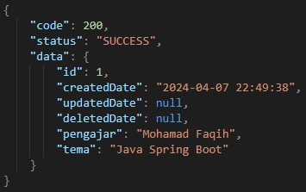

1. **PUT - {{host}}/v1/idstar/training/update**

**Request Body :**

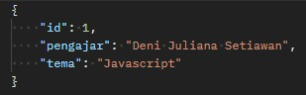

**Response Body :**

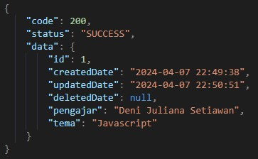

1. **GET LIST - {{host}}/v1/idstar/training/list**

**Request Body :**

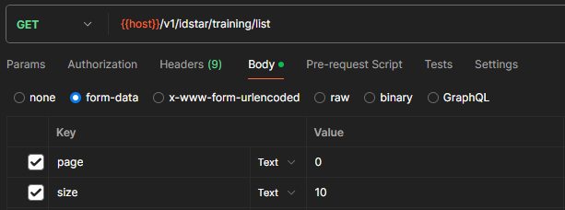

Response Body :

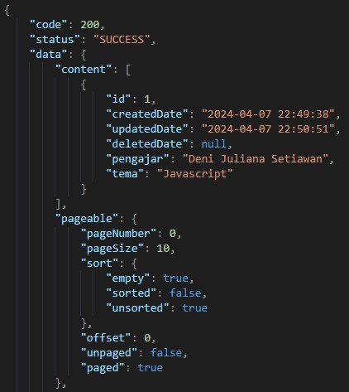

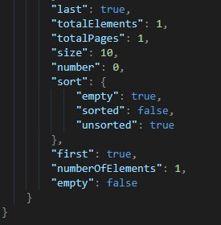

1. **GET ID - {{host}}/v1/idstar/training/{id}**

Request Body :



Response Body :

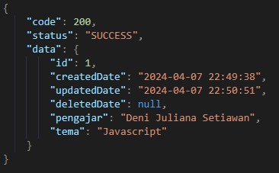

1. **DELETE - {{host}}/v1/idstar/training/delete**

**Request Body :**



**Response Body :**



# 4. Rest API Untuk KaryawanTraining

1. **POST - {{host}}/v1/idstar/karyawan-training/save**

**Request Body :**

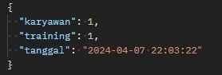

**Response Body :**

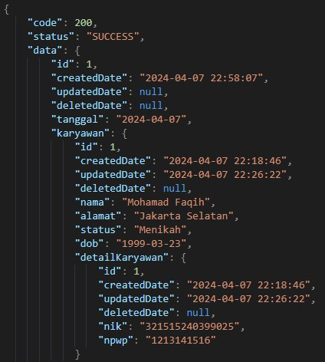

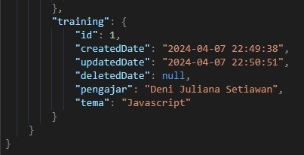

1. **PUT - {{host}}/v1/idstar/karyawan-training/update**

**Request Body :**

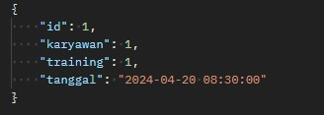

**Response Body :**

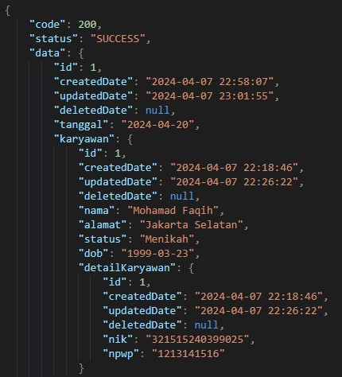



1. **GET LIST - {{host}}/v1/idstar/karyawan-training/list**

**Request Body :**

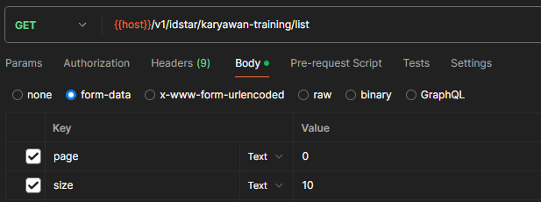

**Response Body :**

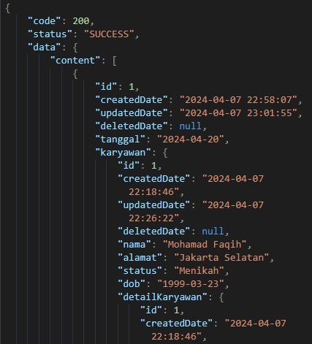

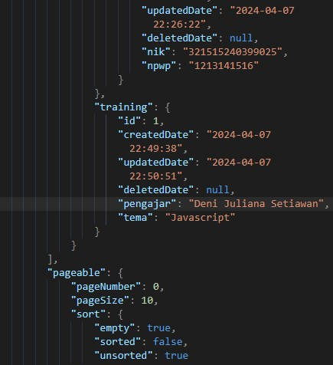

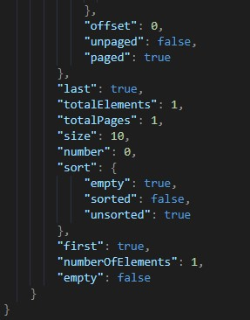

1. **GET ID - {{host}}/v1/idstar/karyawan-training/{id}**

**Request Body :**



**Request Body :**

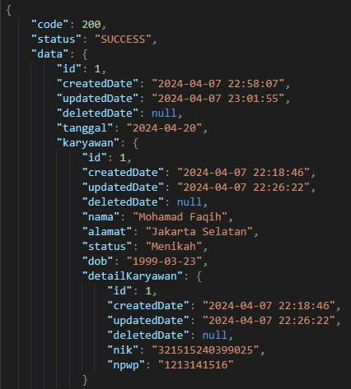

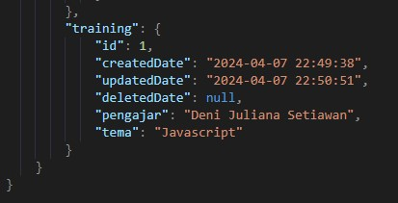

1. **DELETE - {{host}}/v1/idstar/karyawan-training/delete**

**Request Body :**



**Response Body :**



“All done create CRUD every REST API, Thank You…”